Ideation Phase
Define the Problem Statements

Date | 15 February 2026
Team ID | LTVIP2026TMIDS54586
Project Name | Prosperity Prognosticator: Startup Success Prediction using ML
Maximum Marks | 4 Marks

Customer Problem Statement Template:
Create a problem statement to understand your customer's point of view. The Customer Problem Statement template helps you focus on what matters to create experiences people will love.
Problem  Statement (PS) | I am  (Customer) | I’m trying to | But | Because | Which makes me feel
PS-1 | An entrepreneur / startup founder looking to understand the chances of my startup succeeding in a competitive market. | Make informed business decisions, secure funding, and improve growth strategies using data-driven insights. | I do not have access to reliable prediction tools or clear insights about which factors influence startup success. | Startup success depends on multiple complex factors such as market conditions, funding, team strength, and business models, which are difficult to analyze manually. | Uncertain, stressed, and at risk of making poor strategic decisions that may lead to business failure.
PS-2 | An investor, business analyst, or stakeholder evaluating startup opportunities. | Identify high-potential startups and minimize investment risks. | There is limited availability of predictive systems that combine historical startup data with intelligent analytics. | Traditional evaluation methods rely heavily on intuition and incomplete data rather than advanced machine learning models. | Unsure about investment decisions and concerned about financial losses.
A well-articulated customer problem statement allows you and your team to find the ideal solution for the challenges your customers face. Throughout the process, you’ll also be able to empathize with your customers, which helps you better understand how they perceive your product or service.
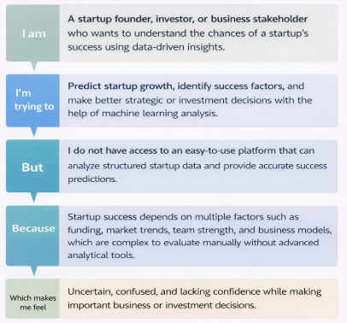
Reference: https://miro.com/templates/customer-problem-statement/ Example:
